# User Story Description

|  |  |
| --- | --- |
| **Use case name** | Candidate Registration |
| **Use case scenario** | Candidate registration scenario |
| **Use case triggering event** | The user will use the PrimeL website to register in order to create an account in PrimeL |
| **Scenario Description** | New candidate(user) details to be entered in the registration form; Email address is the registration ID, First Name, Last Name, Date of Birth, Gender, Phone Number, Experience – Company, Role, Period of Work, Education – University, Year of Study, Interested areas |
| **Primary actor** | New Candidate(User) |
| **Related use cases** | Include: Client Registration, User Login |
| **Precondition** | User needs to have an email address, and the fields entered should be correct |
| **Post condition** | Selected details should be associated with the user  The web application will successfully register the candidate  The web application will generate login details for the candidate after registration  If unsuccessful the registration process will rollback and candidate advise accordingly |
|  | Actor The web application |
| **Flow of activities** | 1.The user will access the PrimeL  website to login |
|  | 2.If user is new that he/she 2.1 Create an account for new  registers user user |
|  | 3.Candidate to enter email address 3.1 Validate Details  which is the registration ID, 3.2 Register user  First Name, Last Name, Date of  Birth, Gender, Phone Number,  Experience – Company, Role,  Period of Work, Education –  University, Year of Study,  Interested areas |
| **Exceptional Conditions** | 3.1 If user enters wrong details, the web application will generate a temporary password and send an email to the user which the user can change afterwards. |
|  | 3.2 If the details are incorrect such as email address, name and mobile number, the web application does not process the registration and facilities for user to enter correct details to proceed to next step or the user can cancel the registration process |

# Design Diagrams

## Use Case Diagram

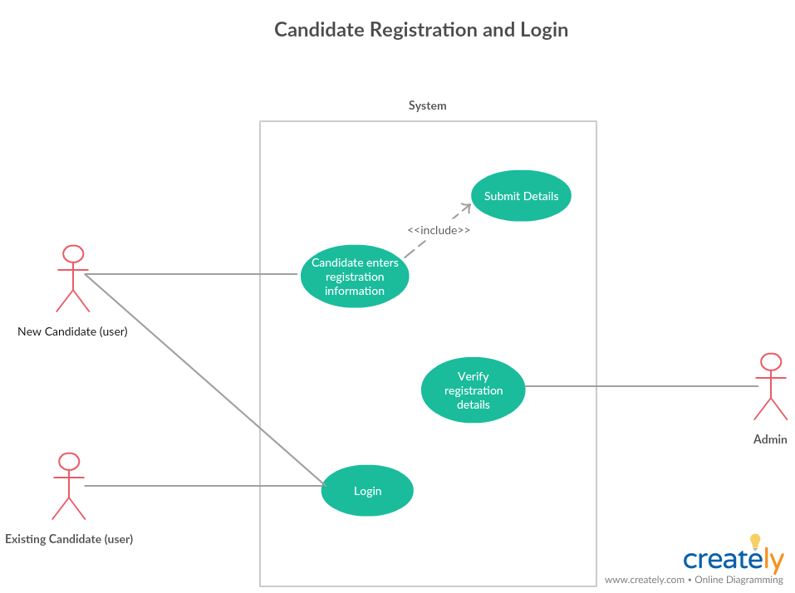

## Process Diagram

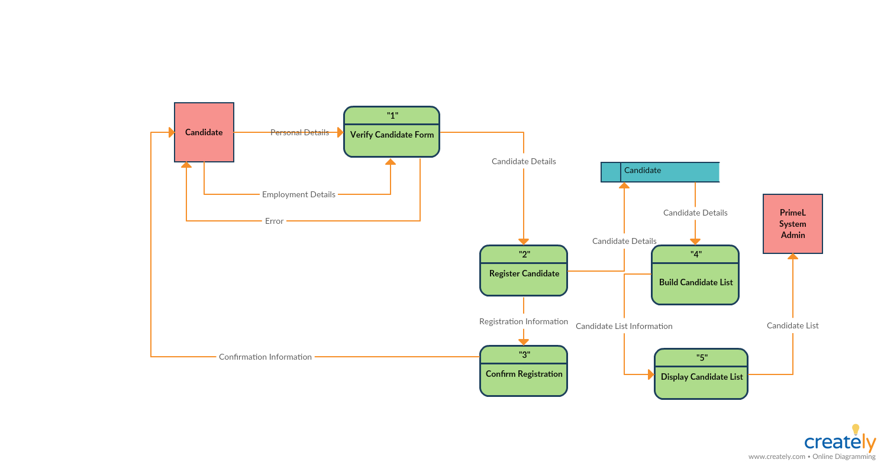

## Sequence Diagram

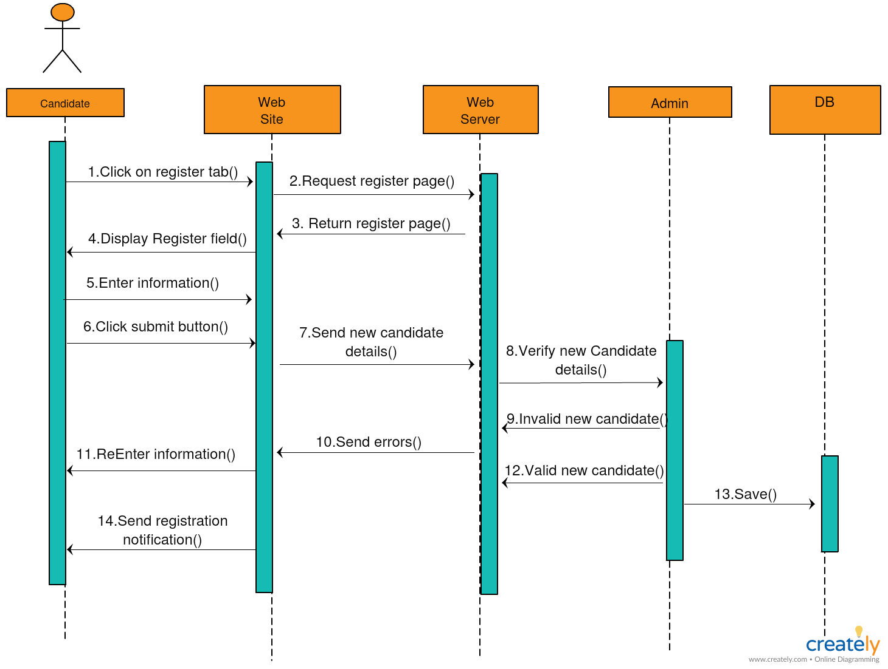

## ER Diagram

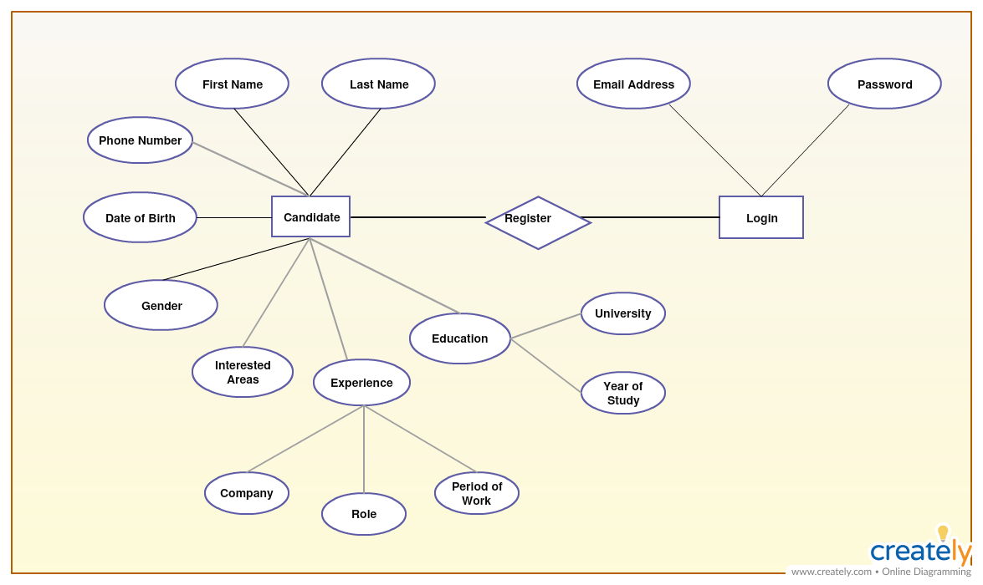

## Wireframe of the Candidate Registration form

